**CENTRAL CITY HAZMAT SCENARIO**

**Unit 2: ICS Fundamentals Review**

**Objective:**

To apply key Unified Command principles.

**Instructions:**

In your assigned groups:

1. Review the following:

Scenario

Scenario Update

Current Resources

Scenario map

1. Complete the following steps:
2. Who has a stake in the incident?
3. Who are the assisting and cooperating agencies?
4. Is this a Single or Unified Command managed incident?
5. If Single Command, who is the Incident Commander and why?
6. If Unified Command, who are the members and why?
7. Draw an Organization Chart for your Incident Command or Unified Command.
8. Identify challenges and safety issues.
9. Record your results on chart paper that can be seen by the entire class.
10. Select a spokesperson and be prepared to present in 30 minutes, the spokesperson should be able to explain the rationale for the group’s decisions.

**Scenario:**

On August 4, at 0835, 10 cars of a southbound freight train derailed on the outskirts of Central City. Beginning with the car immediately behind the engine, the cargo includes:

Cars 1-4: Newsprint

Car 5: Molten sulfur

Car 6: White phosphorus

Car 7: Tallow

Cars 8-10: Empty car carriers

The derailment occurred on a Great Atlantic and Pacific Railroad bridge over Roaring River near a residential area. Cars 5 through 7 are extensively damaged and on fire. The primary concern is the phosphorus car. Phosphorus self-ignites in the presence of oxygen and is water reactive. Phosphorus fires can be controlled by excluding oxygen with water or foam, and/or reducing the temperature below the level required for self-ignition.

**Scenario Update:**

The Incident Commander briefed the Emergency Manager on the potential need for major evacuation, and suggested they open the Emergency Operations Center (EOC) per the Emergency Operations Plan. The EOC has contacted a school bus service for buses and the American Red Cross to open shelter for evacuees. A Staging Area was established at Central City Junior High–AA and 19th Street.

The EOC has briefed the Central City mayor and police chief. The police chief is concerned about the location of the ICP. In conjunction with the Incident Commander, it was determined that a full Command and General Staff is required by the next Operational Period.

The Incident Commander has requested that a Police Duty Officer respond to the ICP to participate in the Unified Command.

**Current Resources:**

**Law Enforcement:**

Central City Police Department Assistant Chief “CC 2”

PIO “CC 5”

Watch Commander Lieutenant “CL 20”

Watch Commander Sergeant “CL 240”

Traffic 10 Supervisor “CCT 10”

Patrol with one officer “CC 241”

Patrol with one officer “CC 242”

Patrol with one officer “CC 243”

Motor Unit with one officer “CM 241”

Motor Unit with one officer “CM 242”

Parking 1 with one officer “CP 1”

Parking 2 with one officer “CP 2”

Columbia State Police Type I Helicopter “SP Air 1”

**Fire Department:**

Central City Fire Department Operations Chief “Chief 2”

Medical Services Officer “Safety 32”

District Chief 1 “DC 1”

Battalion Chief 8 “BC 8”

Type I Engine 1 with 5 personnel “E1”

HazMat 1 with 5 personnel “HazMat 1”

Decon Squad with 2 personnel “Squad 1”

RIT Squad with 3 personnel “RIT 1”

Reserve Foam with 1 personnel “RF4”

Type I Engine 6 with 5 personnel “E6”

Type I Engine 7 with 5 personnel “E7”

Type I Engine 8 with 5 personnel “E8”

Air Unit with 1 personnel “Air 6”

**Emergency Medical Services:**

Central City EMS EMS Supervisor “EMS 100”

ALS Type I with 2 Paramedic “M 1”

ALS Type II with 2 Paramedic “M 7”

BLS Type IV with 2 EMTs “A 6”

BLS Type IV with 2 EMTs “A 8”

MCI Type I (100 pts.) with 1 EMT “MCSV 1”

**Emergency Management:**

EM Director Mary Smith “EM1”

Public Information Officer Beth Price “EM 2”

Central City Coordinator John Walls “EM5”

**Liberty County Public Health:**

Environmental Health Registered Environmental Health Specialist

Great Atlantic and Pacific Railroad:

RR Transport Safety Specialist

**Map:**

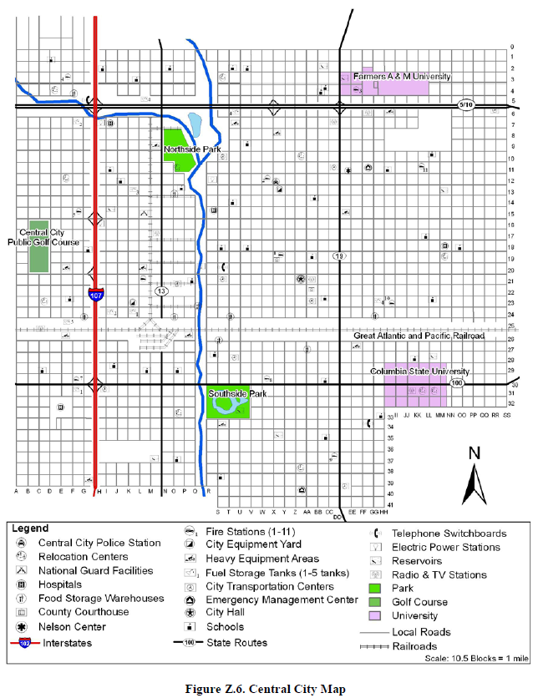

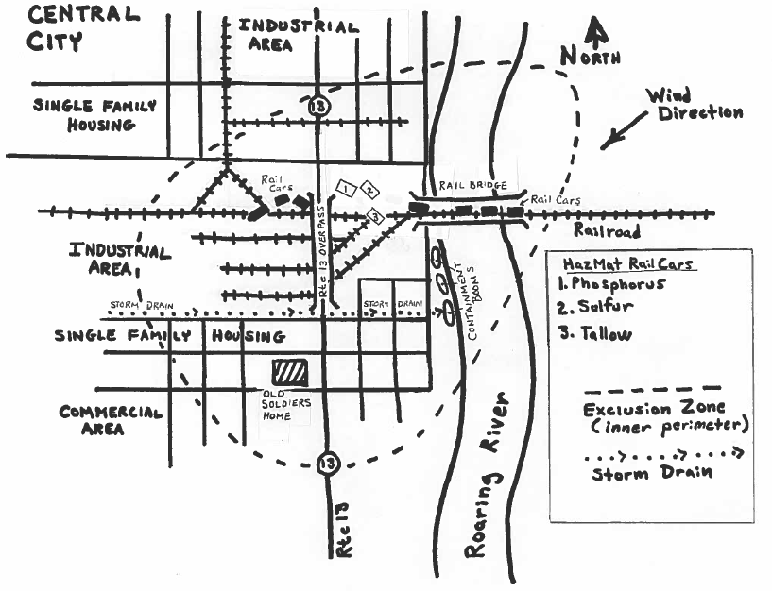

**Your Notes:**

**CENTRAL CITY HAZMAT SCENARIO**

**Unit 3: Initial Actions for Unified Command**

**Objective:**

To organize groups into Incident Management Groups; review and complete ICS Form 201, Incident Briefing; and identify issues related to the simulated incident.

**Instructions:**

Work in your groups to complete the following activity:

1. Review the scenario update.
2. Given a partially completed ICS Form 201 and the scenario information, complete the missing elements on the ICS Form 201.
3. Determine what Command and General positions will be staffed, depict on an organizational chart and be prepared to describe and explain.
4. Using the initial objectives from the ICS Form 201, develop incident objectives for the **next** Operational Period.
5. Document your objectives and organization on chart paper. Make sure your objectives are SMART!
6. Select a spokesperson and be prepared to describe and explain the rationale for your objectives and organization in 30 minutes.

**Scenario Update:**

The exclusion zone has been established and HazMat Groups have been reporting on contents of rail cars, hazards, evacuation zone, and strategic options.

Central City Engine E-1, E-6, E-7 and E-8 have been assigned to primary search and evacuation of residences and businesses in the exclusion zone.

A railroad representative, Jim Neibuhr, is on site and participating as technical specialist.

The Old Soldier’s Home has 12 non-ambulatory patients. Truck 1 was assigned to support the evacuation. Three engines and six BLS ambulances have been ordered for transport.

The County Emergency Manager has been asked to coordinate shelter location.

**INCIDENT BRIEFING (ICS FORM 201)**

**Partially Completed ICS Form 201 for Student Activity –** Refer to ICS_300_AAM_CCHS_ICS_Form_201_STUDENT.pdf

**Your Notes:**

**CENTRAL CITY HAZMAT SCENARIO**

**Unit 4: Implementing an Operational Planning Process**

**Objective:**

To select tactics and conduct safety analysis for the next Operational Period resulting in the completion of ICS Forms 215 and 215A. Students may use the tactics meeting agenda as a template when conducting their group discussions.

**Instructions:**

Ask the students to work in groups to complete the following activity:

1. Review the following in your handouts:

Scenario Update

Operations Section Organizational Chart for the next Operational Period

Updated Incident Objectives for next Operational Period

Technical Specialist Report

Updated Incident Maps

Resources List

Partially completed ICS Form 215

Blank ICS Form 215A

1. Complete the ICS Form 215 using the available information.

Point out that the Operational Planning Worksheet (ICS Form 215) has the information needed to complete tactical direction for the incident. Four Divisions have been established and additional law enforcement resources identified.

1. Based on the tactics selected on the ICS Form 215, complete the Safety Analysis (ICS Form 215A).
2. Be prepared to present in 60 minutes.

**Scenario Update:**

It is now 1200. Your Incident Management Team (IMT) has formally assumed command of the Central City incident. In the 2 hours since your identification of issues and setting of initial objectives, the Hazardous Materials Team’s technical report was submitted, the tactical recommendation was accepted, and (with your concurrence) two additional objectives have been implemented:

1. Keep runoff from entering Roaring River. Measures should be in place no later than 1200. (This has been completed: A containment system has been set up to limit pollution and capture runoff on Roaring River.)
2. Expand the evacuation zone to 2.5 miles downwind (east) of the incident, to be completed no later than 1500.

Note: These objectives have been developed and staffed and have either been completed or are currently being implemented. Both will be complete before the next operational period begins. The rescue/evacuation of the businesses, residences, and Old Soldier’s Home have been completed.

Your team has decided to have a new operational period begin at 1800 August 4 and end at 0600 August 5.

In his final closeout with your team, Initial Incident Commander Ralph Wilkins points out that at 1800 all evacuations should be complete, and the tactical complexity of the incident will be reduced to maintaining the perimeter, containment of runoff, and monitoring the burnoff. To this point, exposure to the burnoff has not been a problem, but as the burnoff escalates, ABC Realty may be at risk. Because there is no immediate need for a medical response, the Incident Commander has put the EMS resources in Staging. Wilkins and your Incident Commander and Operations Section Chief have drafted some incident objectives for the next operational period, held a brief strategy meeting, and scratched out a possible organization structure.

The following updated incident objectives are provided by the Incident Commander:

1. Ensure safety of responders by all personnel operating within the exclusion zone and plume by wearing positive-pressure, Self-Contained Breathing Apparatus (SCBA) and full turn-outs for the duration of the incident.
2. Maintain evacuation perimeters. No unauthorized access without prior notification of and permission from the Incident Commander.
3. Use barrier tape to mark the exclusion zone (inner perimeter) by 1900.
4. Maintain current hazmat containment until cleanup has been completed.
5. Provide exposure protection by 1900.
6. Maintain capability for medical response until cleanup has been completed.

**Current Organizational Chart:**

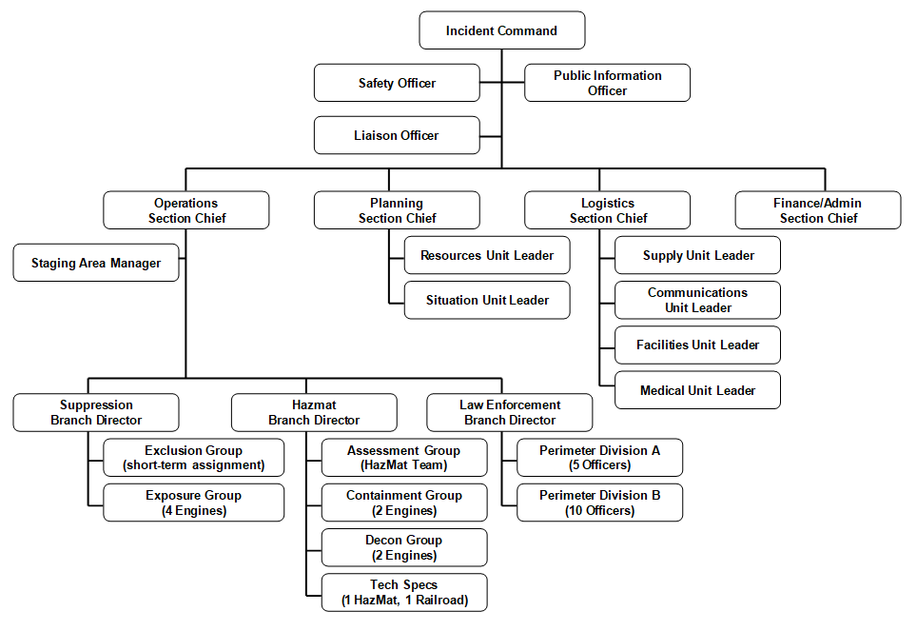

**INCIDENT OBJECTIVES (ICS FORM 202)**

**Updated Incident Objectives for Next Operational Period:**

Refer to ICS_300_AAM_CCHS_ICS_Form_202.pdf

**ICS Form 202**

**Incident Objectives**

**Purpose.** The Incident Objectives (ICS Form 202) describes the basic incident strategy, incident objectives, command emphasis/priorities, and safety considerations for use during the next operational period.

**Preparation.** The ICS Form 202 is completed by the Planning Section following each Command and General Staff meeting conducted to prepare the Incident Action Plan (IAP). In case of a Unified Command, one Incident Commander (IC) may approve the ICS Form 202. If additional IC signatures are used, attach a blank page.

**Distribution.** The ICS Form 202 may be reproduced with the IAP and may be part of the IAP and given to all supervisory personnel at the Section, Branch, Division/Group, and Unit levels. All completed original forms must be given to the Documentation Unit.

**Notes:**

**The ICS Form 202 is part of the IAP and can be used as the opening or cover page.**

**If additional pages are needed, use a blank ICS Form 202 and repaginate as needed.**

**Technical Specialist Report: 8-4: 1000 hours**

**Hazard Analysis:**

* Tanker 5 contains molten sulfur.
* Tanker 6 contains white phosphorus.
* Tanker 7 contains tallow.
* Other cars are empty or not involved.

When burned in dry air, phosphorus generates phosphoric anhydride (phosphoric acid) as a by-product of combustion. In addition to being corrosive to skin and tissue, exposure to phosphoric anhydride may cause severe gastrointestinal irritation, nausea, vomiting, and breathing difficulties.

Because the phosphorus car and the molten sulfur car are both breached, the resultant combined products of combustion are also of concern. These include phosphorus pentasulfide, which is readily converted in the presence of moisture to hydrogen sulfide gas and phosphoric acid. Hydrogen sulfide is a rapid systemic poison that induces respiratory paralysis with consequent asphyxia at high concentrations. Serious health effects such as central nervous system distress, pulmonary edema, and gastrointestinal disturbances may be observed at lower concentrations. Samples indicate that the two products have combined.

In addition to the hazards presented by the sulfur and phosphorus, the tallow also presents an environmental problem. Tallow coats the gills of fish. Tallow has entered Wilson Creek, and dead fish are already present.

**Weather:** No significant change in the next 24 to 36 hours.

**Technical Specialist Report (Continued)**

|  |  |
| --- | --- |
| **Strategic/Tactical Option** | **Analysis** |
| 1. Patch phosphorus tanker. | **Not recommended.** Tear is too extensive, success uncertain, and hazards to responders too great. |
| 2. Foam phosphorus tanker. | **Not recommended.** Adequate amounts of foam will take  48-72 hours to arrive. |
| 3. Bury tanker in wet sand or dirt. | **Not recommended.** Car cannot be moved safely without potential of catastrophic breach and release. Car is pre-1970 construction and predates additional safety regulations imposed at that time. |
| 4. Continue current strategy. | **Not recommended.** Water supply is not adequate to provide enough water to control fire and does nothing to promote resolution of the incident. In addition, more water will continue to erode the bridge abutment, and increase the contamination in Wilson Creek. Fog stream causes caustic by-products to form, endangering responders and the environment. |
| 5. Conduct controlled burn-off until amount of phosphorus has been reduced to the point where car can be moved safely. | **Recommended.** Rate of burn will depend on surface area exposed to oxygen. At current rate of burn, estimated time to burn off remaining phosphorus is 36-48 hours. Projected weather conditions, negative health effects are possible up to 2 miles downwind. Population in impact area: 3,000.  **Special considerations:** City Hall, Police Department, and Fire Station 1/Administration buildings are within the 2-mile zone. Central City General Hospital is .25 miles outside the 2-mile zone. Custer Circle Assisted Living Center is within the 2-mile zone. All facilities have the ability to shelter in place. |

**Updated Incident Maps:**

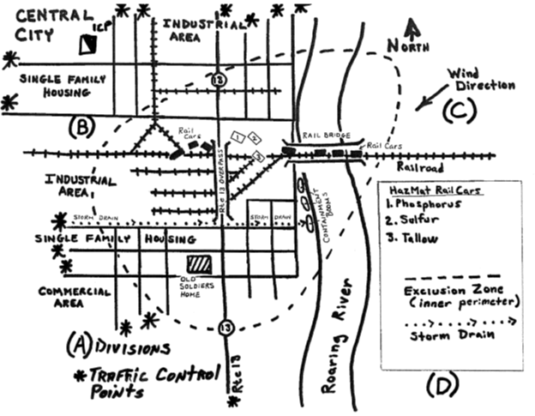

**Resources List:**

**Jurisdiction’s Emergency Resource Inventory:**

|  |  |  |
| --- | --- | --- |
| **Resource** | **Kind** | **Number & Type** |
| Central City Police | Patrol Car | 4 marked units: M-1, M-2, M-3, and M-4  2 unmarked units: M-5 and M-6 |
| Wilsonville Police | Patrol Car | 4 marked units: P-1, P-2, P-3, and P-4 |
| Liberty County Sheriff | Patrol Car | 6 marked units: O-1, O-2, O-3, O-4, O-5, and O-6 |
| State Police | Patrol Car | 1 marked unit: SP-1  1 unmarked unit: SP-2 |
| Central City Fire/Rescue | Engine Company  Truck Company  Rescue Company  Heavy Rescue | 3 companies: CCE-1, CCE-6, CCE 7, and CCE-8  Air 6 |
| Other Local Fire | Engine Company  Truck Company  Rescue Company | 5 companies: OF-1, OF-2, OF-3, OF-4, and OF-5  3 companies: OTR-1, OTR-2, and OTR-3  1 company: OHR-1 |
| Central City EMS | BLS  ALS  Medevac  Off-Duty Personnel (full-time and volunteer) | 2 units: A 6, A 8  2 units: M1, M7  Lifelight 324CC Helicopter  33 |
| Central City Public Works | Front-End Loaders  Dump Trucks | 3  4 |
| Other Local EMS | BLS  ALS | 5 units: OBLS-1, OBLS-2, OBLS-3, OBLS-4, and OBLS-5  2 units: OALS-1 and OALS-2 |
| Other Local Resources | Central City/Liberty County Regional Hazmat Team  School Buses  Electrical Utility Company  Gas Company | 1  12  2  4 |
| Available through mutual aid with adjacent counties and their communities | Engine Company  Truck Company  Patrol Car  County Dump Truck  Front-End Loader  Bulldozer  Crime Scene Investigation  County and State Engineer | 6  4  12  5  2  2  1 unit  3 |

**Additional Available Resources: Not Ordered At This Time**

**National Guard:**

80 personnel

5 five-ton trucks

1 engineer unit with 8 personnel

2 heavy front-end loaders

1 bulldozer

**Air Operations:**

2 helicopters and support assets capable of basic medical transport

3 State Police helicopters, MEDEVAC equipped

**State Police:**

15 marked units

Hazardous Materials Response Team

**Incident Communications:**

Central City and Liberty County have a shared 800-mHz radio system. Talk Groups include:

Fire: Talk Groups 1, 2, 3

Law Enforcement: Talk Groups 4, 5, 6

EMS: Talk Groups 7, 8

Regional Mutual Aid: Talk Groups 9, 10

State Mutual Aid: Talk Group 11

The railroad company does not share a radio frequency or talk group with any of the above.

Central City General Hospital is 10 minutes flight time, 45 minutes driving time away from the incident. Operations have kept 1 ALS and 3 BLS ambulances in Staging.

**OPERATIONAL PLANNING WORKSHEET (ICS FORM 215)**

**Partially Completed ICS Form 215:**

Refer to ICS_300_AAM_CCHS_ICS_Form_215.pdf

**Blank ICS Form 215A:**

Refer to ICS_300_AAM_CCHS_ICS_Form_215A.pdf

**Your Notes:**

**CENTRAL CITY HAZMAT SCENARIO**

**Unit 5: Planning Process, IAP, and Operations Brief**

**Objective:**

To complete the planning cycle by developing a written IAP, developing the Operations Briefing agenda, and conducting an Operations Briefing for a simulated incident.

This activity is divided into two components. In Part 1, students will prepare an Incident Action Plan (IAP). In Part 2, students will develop the Operations Briefing agenda and then outbrief the IAP (developed in Part 1) in an Operations Briefing.

**Instructions for Part 1:**

Ask the students to work in groups to complete the following activity:

1. Prepare an Incident Action Plan, using (at a minimum) ICS Forms 202, 203, 204(s), 205, 206, 207 and 208.
2. Be prepared to finish in 45 minutes.

**Instructions for Part 2:**

Ask the students to work in groups to complete the following activity:

1. Outline the agenda for the Operations Briefing.
2. Select a spokesperson to present your IAP as a concise 5- to 10-minute Operations Briefing. Be prepared to present in 15 minutes.
3. Provide students with blank copies of the ICS Forms located in the Appendix.

**CENTRAL CITY HAZMAT SCENARIO**

**Unit 6: Incident Resource Management**

**Objective:**

To describe how resources are ordered and to identify the challenges and strategies for managing resources during an incident.

**Instructions:**

Ask the students to work in groups to complete the following activity, given your scenario:

1. Review the Operational Planning Worksheet (ICS Form 215) and Safety Analysis (ICS Form 215A) completed in the previous unit.
2. Describe how resources will be ordered (single point or multipoint) for this incident, from what sources resources will be acquired, and how long they will need to be deployed.
3. Identify the top challenges and strategies for managing resources during this incident.
4. Describe the method for evaluating resource effectiveness.
5. Select a spokesperson and be prepared to present your work in 30 minutes.

**Your Notes:**

**CENTRAL CITY HAZMAT SCENARIO**

**Unit 7: Demobilization, Transfer of Command, Closeout, & Transition to Recovery**

**Objective:**

To identify demobilization considerations, given the threaded scenario.

**Instructions:**

Ask the students to work in groups to complete the following activity:

1. Review the information you developed in the previous activities, the scenario update and the 5 elements of a Demobilization Plan.
2. Write 5 considerations for demobilization for your scenario on an easel chart.
3. Based on your scenario, are there any unique demobilization release priorities?
4. Select a spokesperson and be prepared to present your work in 15 minutes.

**Demobilization Considerations:**

No personnel or equipment are to be released without specific instructions.

Logistics will manage transport of personnel/equipment.

Criteria for safe release of personnel, including medical issues, must be included.

Reporting criteria to Demobilization Unit Leader must be included.

Travel parameters, notification upon arrival, and timeframes must be included.

Release priorities must be determined.

Release procedures must be determined.

Agency policy is that the Command and General Staff will demobilize as a group after the final transfer of command to the cleanup company and agency closeout.

1. Continue with this process until all groups have presented.

**Scenario Update:**

It is now 1200 August 8, nearly 48 hours since the controlled burn-off began.

Enough phosphorus has burned off that it is now safe to move the tank cars involved in the derailment.

The outer perimeter has been released.

Evacuees have been allowed to return and businesses to reopen.

The National Transportation Safety Board (NTSB) has completed its on-scene investigations.

Incident Command determines that the incident priorities will now be restructured to focus on debris removal and cleanup rather than response.

**New Incident Objectives:**

Provide for responder safety as per department SOP for the duration of the incident.

Evaluate, and report back, the structural integrity of the rail bed to allow for safe removal of rail cars by 1600 August 8.

Maintain inner perimeter until exclusion zone is declared safe by HazMat Team. Limit access to authorized personnel wearing appropriate Personal Protective Equipment (PPE). (See Safety Message for specific PPE instructions.)

Conduct soil and water sampling by 1600 on August 8 to determine extent of cleanup required. Water and soil should be sampled to depth and lateral distance indicated by plume model.

**Current Organization Chart:**

organizational chart that depicts an Incident Management team structure: Incident commander at top, followed by Command staff (Safety officer, public information officer, liaison officer), followed by the General staff (Operations, Planning, Logistics, Finance/Admin Section Chiefs). Under operations section chief reside inner perimeter group sup, sampling hazmat 1 (single resource), decon hazmat1 (single resource), under Inner perimeter group supervisor is CC engine 1 and 6